Contents

INSTALLATION OF React-Bootstrap: 2

Run code in terminal: 2

Import bootstrap in index.js 2

HEADER COMPONENT 2

Create Header.js file inside components folder. 2

Create NavBar using bootstrap 3

INSTALL React-icons in terminal 4

CREATING PAGE ROUTES 5

INSTALL react-router-dom 5

SETUP CONTEXT API 6

GENERATING PRODUCTS JSON 7

Installation 7

useReducer Hook 8

HOME PAGE UI 9

Sending props to SingleProduct.js 10

FILTER COMPONENT UI 11

RATING COMPONENT UI 13

SINGLE PRODUCT COMPONENT UI 15

TO PREVENT DATA TO CHANGE EVERY UPDATE 15

ADD/ REMOVE FROM CART FUNCTIONALITY 16

IMPORTING CONTEXT STATE i.e. CartState() 17

HEADER CART DROPDOWN 19

GO TO CART BUTTON 21

CART PAGE 21

CREATING BETTER VIEW FOR PRODUCTS IN CART 22

CHANGE CART QUANTITY FUNCTIONALITY 25

Add action type in reducer.js 25

FILTERS IMPLEMENTATION 25

Filters useReducer: 25

CREATE USEREDUCER IN CONTEXT.JS 25

CREATING productReducer IN Reducers.js 26

Import productReducer in Context.js 26

MANIPULATE STATE IN REDUCERS 26

NOW IMPLEMENTING ON OUR APP 27

NOW SEARCH BUTTON OF HEADER.JS 30

TRANSFORM PRODUCTS LOGIC 31

First bring all product state from context api 31

Logical Function to render products according to filters 31

Return method of Home.js 31

Displaying those which are out of stock in home.js 32

Displaying those which are fast delivery in home.js 32

Displaying according to rating filters 32

Searching 32

MOBILE RESPONSIVE STYLES 32

# INSTALLATION OF React-Bootstrap:

<https://react-bootstrap-v4.netlify.app/getting-started/introduction>

## Run code in terminal:

npm install react-bootstrap bootstrap@4.6.0

## Import bootstrap in index.js

import 'bootstrap/dist/css/bootstrap.min.css';

# HEADER COMPONENT

## Create Header.js file inside components folder.

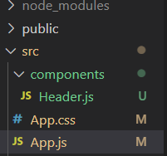

App.js

import './App.css';

import Header from './components/Header';

function App() {

  return (

    <div className="App">

      <Header/>

    </div>

  );

}

export default App;

## Create NavBar using bootstrap

Header.js

import React from 'react'

import { Container,FormControl,Navbar,Dropdown } from 'react-bootstrap'

const Header = () => {

    return (

        <Navbar bg='dark' variant='dark'

        style={{height:80}}>

            <Container>

                <Navbar.Brand>

                    <a href="/">Yakkha Bakery Shop</a>

                </Navbar.Brand>

                <Navbar.Text className='search'>

                    <FormControl

                        style={{width:500}}

                        placeholder='Search our products'

                        className='m-auto'

                    />

                </Navbar.Text>

                <Dropdown>

                <Dropdown.Toggle variant="success" id="dropdown-basic">

                    Dropdown Button

                </Dropdown.Toggle>

                <Dropdown.Menu>

                    <Dropdown.Item href="#/action-1">Action</Dropdown.Item>

                    <Dropdown.Item href="#/action-2">Another action</Dropdown.Item>

                    <Dropdown.Item href="#/action-3">Something else</Dropdown.Item>

                </Dropdown.Menu>

                </Dropdown>

            </Container>

        </Navbar>

    )

}

export default Header

App.css

a{

    text-decoration: none !important;

    color: inherit !important;

}

## INSTALL React-icons in terminal

npm install react-icons --save

Header.js

import React from 'react'

import { Container,FormControl,Navbar,Dropdown } from 'react-bootstrap'

const Header = () => {

    return (

        <Navbar bg='dark' variant='dark'

        style={{height:80}}>

            <Container>

                <Navbar.Brand>

                    <a href="/">Yakkha Bakery Shop</a>

                </Navbar.Brand>

                <Navbar.Text className='search'>

                    <FormControl

                        style={{width:500}}

                        placeholder='Search our products'

                        className='m-auto'

                    />

                </Navbar.Text>

                <Dropdown alignRight>

                <Dropdown.Toggle variant="success" id="dropdown-basic">

                    Dropdown Button

                </Dropdown.Toggle>

                <Dropdown.Menu>

                    <Dropdown.Item href="#/action-1">Action</Dropdown.Item>

                    <Dropdown.Item href="#/action-2">Another action</Dropdown.Item>

                    <Dropdown.Item href="#/action-3">Something else</Dropdown.Item>

                </Dropdown.Menu>

                </Dropdown>

            </Container>

        </Navbar>

    )

}

export default Header

# CREATING PAGE ROUTES

## INSTALL react-router-dom

* npm i react-router-dom

App.js

import { BrowserRouter,Route,Switch } from 'react-router-dom';

import './App.css';

import Header from './components/Header';

import Home from './components/Home';

import Cart from './components/Cart';

function App() {

  return (

    <BrowserRouter>

      <Header/>

      <div>

      <Switch>

        <Route path='/' exact>

          <Home />

        </Route>

        <Route path='/cart' exact>

          <Cart />

        </Route>

      </Switch>

      </div>

    </BrowserRouter>

  );

}

export default App;

Header.js

 <Navbar.Brand>

      <Link to="/">Yakkha Bakery Shop</Link>

 </Navbar.Brand>

Folder:

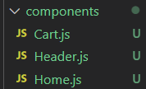

# SETUP CONTEXT API

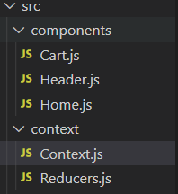

Context.js

import React from 'react'

import {createContext} from "react";

const Cart = createContext();

const Context = ({children }) => {

    return (

        <Cart.Provider>

             {children}

        </Cart.Provider>

    )

}

export default Context;

Index.js

import React from 'react';

import ReactDOM from 'react-dom';

import './index.css';

import App from './App';

import 'bootstrap/dist/css/bootstrap.min.css';

import Context from "./context/Context";

ReactDOM.render(

  <React.StrictMode>

    <Context>

      <App />

    </Context>

  </React.StrictMode>,

  document.getElementById('root')

);

# GENERATING PRODUCTS JSON

We will use faker to create fake json.

Installation: npm i faker

Context.js

import React from 'react'

import {createContext} from "react";

import faker from "faker";

const Cart = createContext();

const Context = ({children }) => {

    //creating fake json

    const products = [...Array(20)].map(() => ({

        id: faker.datatype.uuid(),

        name: faker.commerce.productName(),

        price: faker.commerce.price(),

        image: faker.random.image(),

        inStock: faker.random.arrayElement([0,3,5,6,7]),

        fastDelivery: faker.datatype.boolean(),

        ratings: faker.random.arrayElement([1,2,3,4,5]),

    }));

    console.log(products);

    return (

        <Cart.Provider>

             {children}

        </Cart.Provider>

    )

}

export default Context;

# useReducer Hook

Context.js

const [state, dispatch] = useReducer(cartReducer, {

        products: products,

        cart: [] //empty array where we will add our products in future

    })

Reducers.js

export const cartReducer = (state,action) => {

    switch (action.type){

        default:

            return state;

    }

};

Import cartReducer in context.js

import { cartReducer } from './Reducers';

Context.js

<Cart.Provider value={{state,dispatch}}>

             {children}

</Cart.Provider>

export default Context;

export const CartState = () =>{

    return useContext(Cart)

}

# HOME PAGE UI

Home.js

import React from 'react'

import {CartState} from '../context/Context';

const Home = () => {

    const {state} = CartState();

    console.log(state);

    return (

        <div>

            Home

        </div>

    )

}

export default Home

SS:

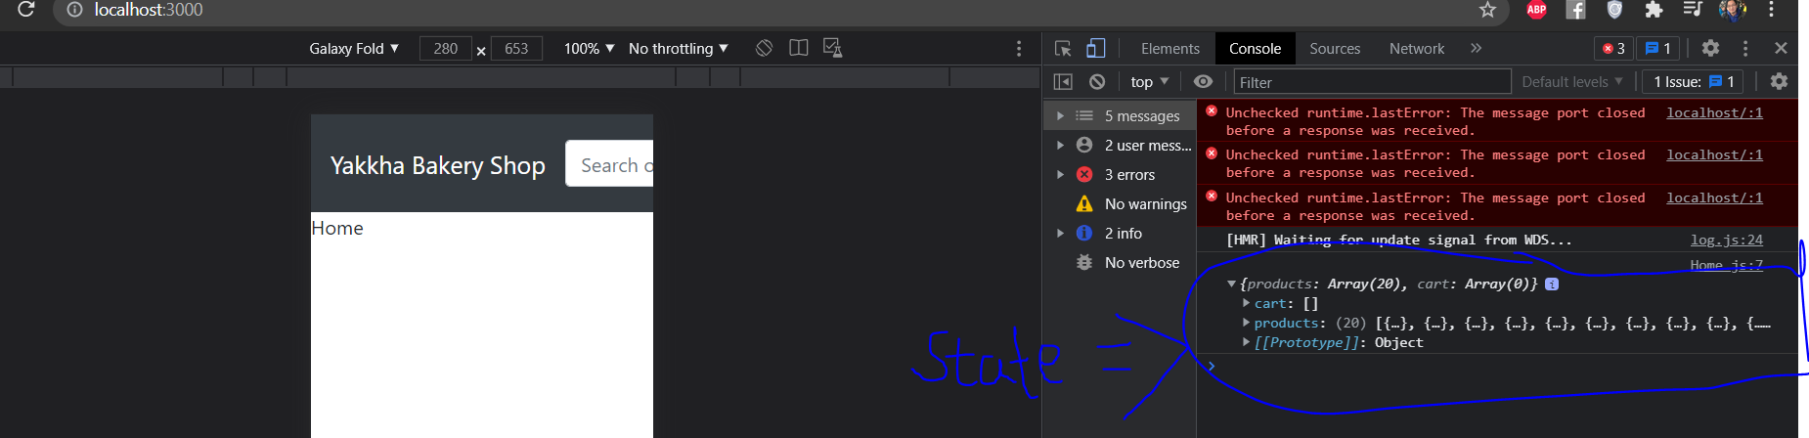

import React from 'react'

import {CartState} from '../context/Context';

const Home = () => {

    const {

        state : {products},

    } = CartState();//only getting products state from context api state

    return (

        <div className='home'>

            {/* <Filters/> */}

            <div className='productContainer'>

                {products.map((prod) => {

                    return <span>{prod.name}</span>

                })}

            </div>

        </div>

    )

}

export default Home

## Sending props to SingleProduct.js

import React from 'react'

import {CartState} from '../context/Context';

import SingleProduct from './SingleProduct';

const Home = () => {

    const {

        state : {products},

    } = CartState();

    return (

        <div className='home'>

            {/* <Filters/> */}

            <div className='productContainer'>

                {products.map((prod,idx) => {

                    return <SingleProduct prod={prod} key={idx} />

                })}

            </div>

        </div>

    )

}

export default Home

SingleProduct.js

import React from 'react'

const SingleProduct = (props) => {

    return (

        <div>

            {props.prod.name}

        </div>

    )

}

export default SingleProduct

styles.css

.home{

    display: flex;

}

.productContainer {

    display: flex;

    width: 78%;

    padding: 20px;

    flex-wrap: wrap;

    justify-content: space-around;

}

# FILTER COMPONENT UI

Filters.js

import React from 'react'

import { Button,Form } from 'react-bootstrap'

const Filters = () => {

    return (

        <div className='filters'>

            <span className='title'>Filter</span>

            <span>

                <Form.Check

                 inline

                 label="Ascending"

                 name="group1"

                 type="radio"

                 id={`inline-1`}

                 />

            </span>

            <span>

                <Form.Check

                 inline

                 label="Descending"

                 name="group1"

                 type="radio"

                 id={`inline-2`}

                 />

            </span>

            <span>

                <Form.Check

                 inline

                 label="Include Out of Stock"

                 name="group1"

                 type="checkbox"

                 id={`inline-3`}

                 />

            </span>

            <span>

                <Form.Check

                 inline

                 label="Fast Delivery Only"

                 name="group1"

                 type="checkbox"

                 id={`inline-4`}

                 />

            </span>

            <span>

                <label style={{paddingRight: 10}}>Rating:</label>

                {/* <Rating rating={byRating} style={{cursor: "pointed"}} /> */}

            </span>

            <Button variant="light">Clear</Button>

        </div>

    )

}

export default Filters

styles.css

.filters {

    background-color: rgb(60, 60, 63);

    color: white;

    padding: 20px;

    display: flex;

    flex-direction: column;

    width: 20%;

    margin: 10px;

    height: 86vh;

}

.filters > span{

    padding-bottom: 20px;

}

.title{

    font-size: 30px;

}

# RATING COMPONENT UI

import React from 'react'

import {AiFillStar,AiOutlineStar} from 'react-icons/ai';

const Rating = (props) => {

    return (

        <div>

            {

                [...Array(5)].map((_,i) => (

                    <span

                    key={i}

                    onClick={() => props.onClick(i)}

                    style={props.style}

                    >

                        {props.rating > i ? (

                            <AiFillStar fontSize="15px" />

                        ) : (

                            <AiOutlineStar fontSize="15px" />

                        )}

                    </span>

                ))

            }

        </div>

    )

}

export default Rating

Filters.js

import React,{useState} from 'react'

import { Button,Form } from 'react-bootstrap'

import Rating from './Rating';

const Filters = () => {

    const [rate, setRate] = useState(0)

    return (

        <div className='filters'>

            <span className='title'>Filter</span>

            <span>

                <Form.Check

                 inline

                 label="Ascending"

                 name="group1"

                 type="radio"

                 id={`inline-1`}

                 />

            </span>

            <span>

                <Form.Check

                 inline

                 label="Descending"

                 name="group1"

                 type="radio"

                 id={`inline-2`}

                 />

            </span>

            <span>

                <Form.Check

                 inline

                 label="Include Out of Stock"

                 name="group1"

                 type="checkbox"

                 id={`inline-3`}

                 />

            </span>

            <span>

                <Form.Check

                 inline

                 label="Fast Delivery Only"

                 name="group1"

                 type="checkbox"

                 id={`inline-4`}

                 />

            </span>

            <span>

                <label style={{paddingRight: 10}}>Rating:</label>

                <Rating

                rating={rate}

                onClick = {(i) => setRate(i+1)}

                style={{cursor: "pointed"}} />

            </span>

            <Button variant="light">Clear</Button>

        </div>

    )

}

export default Filters

# SINGLE PRODUCT COMPONENT UI

## TO PREVENT DATA TO CHANGE EVERY UPDATE

Context.js

const Cart = createContext();

faker.seed(99);//so data wont change every update

SingleProduct.js

import React from 'react'

import {Card,Button } from "react-bootstrap";

import Rating from './Rating';

const SingleProduct = ({prod}) => {

    return (

        <div className="products">

            <Card>

                <Card.Img

                variant="top"

                src={prod.image}

                alt={prod.name}

                />

                <Card.Body>

                    <Card.Title>

                        {prod.name}

                    </Card.Title>

                    <Card.Subtitle

                    style={{paddingBottom: 10}}>

                    <span>Rs {prod.price.split(".")[0]}</span>

                    {prod.fastDelivery ? (

                        <div>Fast Delivery</div>

                    ) : (

                        <div>4 Days Delivery</div>

                    )}

                    <Rating rating={prod.ratings} />

                    </Card.Subtitle>

                    <Button variant="danger">Remove from cart</Button>

                    <Button disabled={!prod.inStock}>

                        {!prod.inStock ? "Out of Stock" : "Add to Cart"}

                    </Button>

                </Card.Body>

            </Card>

        </div>

    )

}

export default SingleProduct

Style.css

.products {

    width: 30%;

    margin: 10px;

}

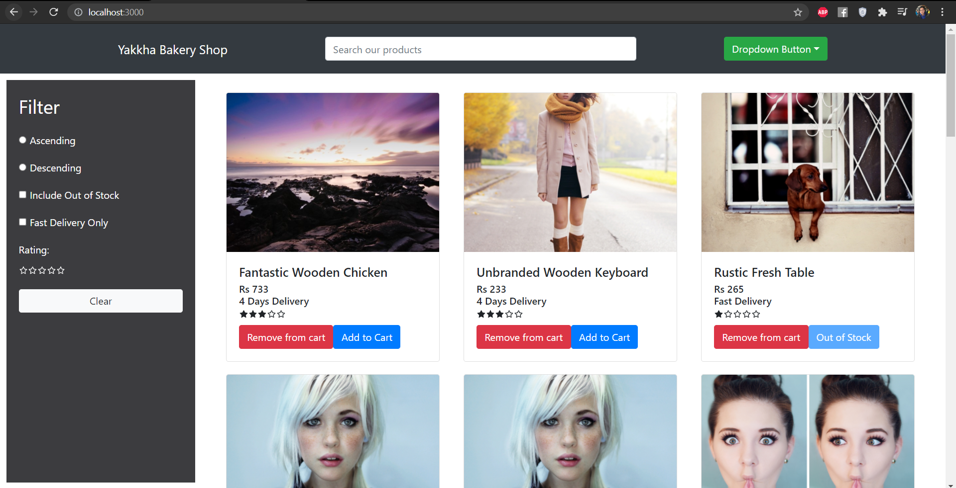

# ADD/ REMOVE FROM CART FUNCTIONALITY

REMEMBER: context.js

 const [state, dispatch] = useReducer(cartReducer, {

        products: products,

        cart: [] //empty array where we will add our products in future

    })

    return (

        //we are not using value rather we will use useReducer hooks

        <Cart.Provider value={{state,dispatch}}>

             {children}

        </Cart.Provider>

    )

}

export default Context;

export const CartState = () =>{

    return useContext(Cart)

}

Reducers.js

export const cartReducer = (state,action) => {

    switch (action.type){

        case "ADD_TO_CART":

            return {...state,

                cart:[...state.cart,

                {

                ...action.payload,

                qty:1

            }]}

        case "REMOVE_FROM_CART":

            return {...state,

                cart:state.cart.filter((c) => c.id !== action.payload.id)}

        default:

            return state;

    }

};

## IMPORTING CONTEXT STATE i.e. CartState()

SingleProducts.js [Import context state]

import React from 'react'

import {Card,Button } from "react-bootstrap";

import Rating from './Rating';

import { CartState } from '../context/Context';

const SingleProduct = ({prod}) => {

    const {

        state: { cart },

        dispatch, //for manuplating states

    } = CartState();

    return (

        <div className="products">

            <Card>

                <Card.Img

                variant="top"

                src={prod.image}

                alt={prod.name}

                />

                <Card.Body>

                    <Card.Title>

                        {prod.name}

                    </Card.Title>

                    <Card.Subtitle

                    style={{paddingBottom: 10}}>

                    <span>Rs {prod.price.split(".")[0]}</span>

                    {prod.fastDelivery ? (

                        <div>Fast Delivery</div>

                    ) : (

                        <div>4 Days Delivery</div>

                    )}

                    <Rating rating={prod.ratings} />

                    </Card.Subtitle>

                    {/* CHECKING if particular things are available

                    in cart or not, showing add or remove on conidtion */}

                    {

                        cart.some(p => p.id === prod.id) ? (

                            <Button

                            onClick={() => {

                                dispatch({

                                    type: 'REMOVE_FROM_CART',

                                    payload: prod

                                })

                            }}

                            variant="danger">Remove from cart</Button>

                        ):(

                            <Button

                            onClick={() => {

                                dispatch({

                                    type: 'ADD_TO_CART',

                                    payload: prod

                                })

                            }}

                            disabled={!prod.inStock}>

                                {!prod.inStock ? "Out of Stock" : "Add to Cart"}

                            </Button>

                        )

                    }

                    {/* onClick function in add button where we use dispatch and

                    it takes two parameters, one for type and another for payload */}

                </Card.Body>

            </Card>

        </div>

    )

}

export default SingleProduct

# HEADER CART DROPDOWN

Header.js

import React from 'react'

import { Container,FormControl,Navbar,Dropdown } from 'react-bootstrap'

import {Link} from "react-router-dom";

import {AiOutlineShoppingCart,AiFillDelete} from "react-icons/ai"

import { CartState } from '../context/Context';

const Header = () => {

    const {

        state: {cart},

        dispatch

    } = CartState()

    return (

        <Navbar bg='dark' variant='dark'

        style={{height:80}}>

            <Container>

                <Navbar.Brand>

                    <Link to="/">Yakkha Bakery Shop</Link>

                </Navbar.Brand>

                <Navbar.Text className='search'>

                    <FormControl

                        style={{width:500}}

                        placeholder='Search our products'

                        className='m-auto'

                    />

                </Navbar.Text>

                <Dropdown alignRight>

                <Dropdown.Toggle variant="success" id="dropdown-basic">

                    <AiOutlineShoppingCart/>  {cart.length}

                </Dropdown.Toggle>

                <Dropdown.Menu style={{ minWidth: 370}}>

                    {cart.length > 0 ? (

                        <>

                        {

                            cart.map((prod)=>(

                                <span className="cartitem" key={prod.id}>

                                <img

                                src={prod.image}

                                className="cartItemImg"

                                alt={prod.name}

                                />

                                <div classNmae="cartItemDetail">

                                    <span>{prod.name}</span>

                                    <span>Rs {prod.price.split(".")[0]}</span>

                                </div>

                                <AiFillDelete

                                onClick={() => {

                                    dispatch({

                                        type: 'REMOVE_FROM_CART',

                                        payload: prod

                                    })

                                }}

                                variant="danger"></AiFillDelete>

                                </span>

                            ))

                        }

                        </>

                    ) : (

                        <Dropdown.Item href="#/action-3">Nothing</Dropdown.Item>

                    )}

                </Dropdown.Menu>

                </Dropdown>

            </Container>

        </Navbar>

    )

}

export default Header

Styles.css

.cartitem{

    display: flex;

    justify-content: space-between;

    align-items: center;

    margin: 0 20px;

    margin-bottom: 20px;

}

.cartItemImg{

    border-radius: 50%;

    width: 50px;

    height: 50px;

    object-fit: cover;

}

.cartItemDetail{

    display: flex;

    flex: 1;

    padding: 0 20px;

    flex-direction: column;

}

## GO TO CART BUTTON

Header.js

 <AiFillDelete

                                onClick={() => {

                                    dispatch({

                                        type: 'REMOVE_FROM_CART',

                                        payload: prod

                                    })

                                }}

                                variant="danger"></AiFillDelete>

                                </span>

                            ))

                        }

                        <Link to="/cart">

                        <Button style={{width: "95%",margin: "0 10px"}}>

                            Go To Cart

                        </Button>

                        </Link>

# CART PAGE

Cart.js

import React,{useEffect,useState} from 'react'

import { Button, ListGroup } from 'react-bootstrap';

import { CartState } from "../context/Context";

const Cart = () => {

    const {

        state: {cart},

        dispatch,

    } = CartState()

    const [total, setTotal] = useState();

    useEffect(() => {

        setTotal(cart.reduce((acc,curr) => acc + Number(curr.price)*curr.qty,0));

    }, [cart]);

    return (

        <div className="home">

           <div className="productContainer">

            <ListGroup>

                {

                    cart.map(prod => (

                        <span>{prod.name}</span>

                    ))

                }

            </ListGroup>

           </div>

           <div className="filters summary">

                <span className="title">Sub Total: {cart.length} items</span>

                <span style={{fontWeight: 700, fontSize: 20}}>Total: Rs {total}</span>

                <Button type="button" disabled={cart.lenth === 0}>

                    Proceed to Checkout

                </Button>

           </div>

        </div>

    )

}

export default Cart

Styles.css

.summary{

    width: 30%;

}

SS:

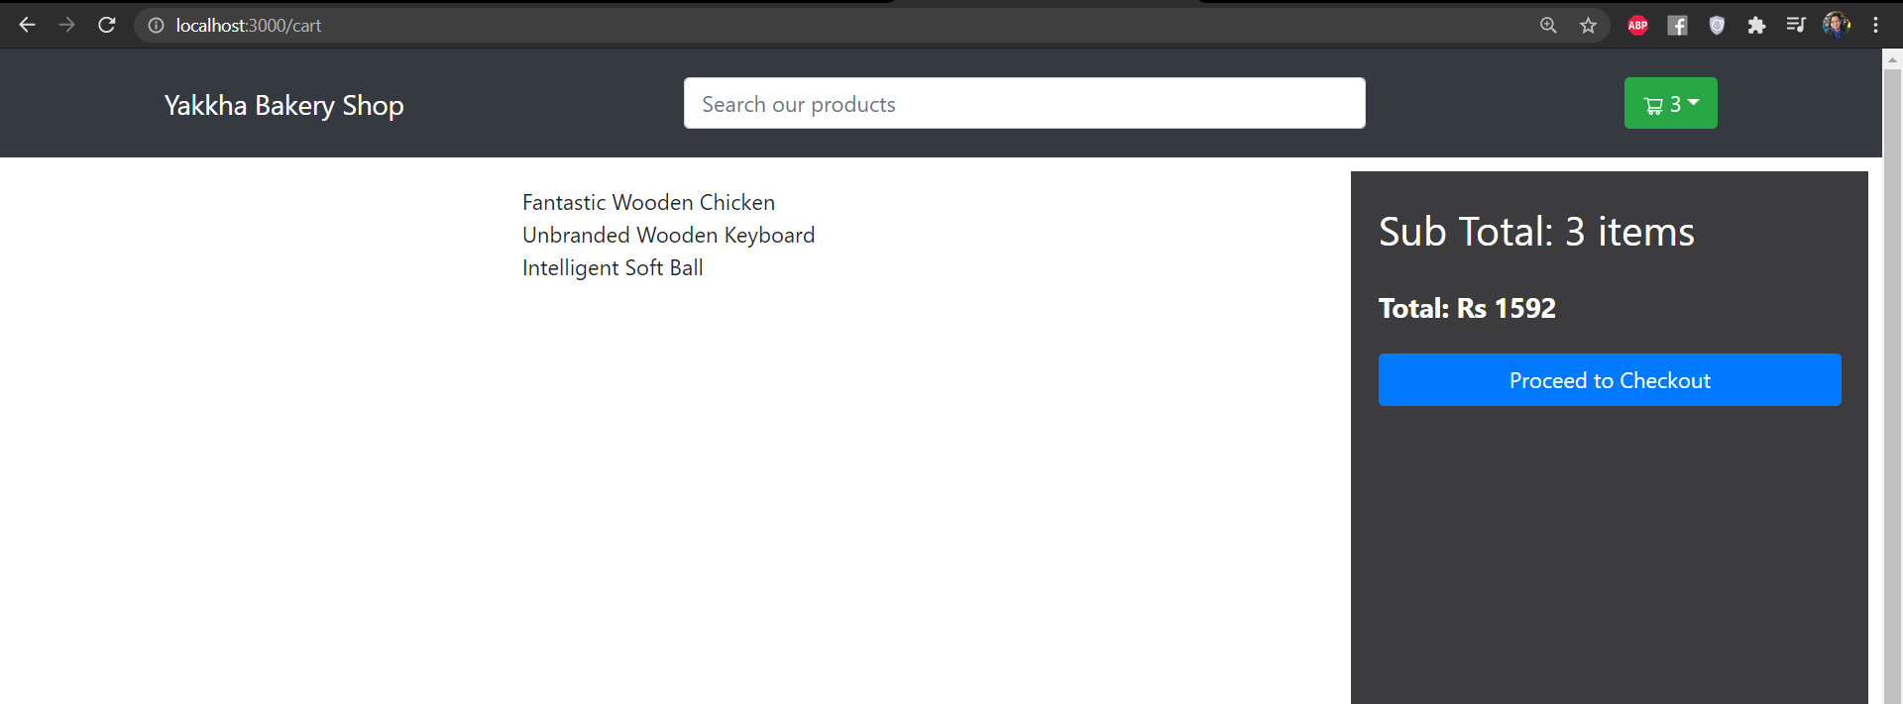

## CREATING BETTER VIEW FOR PRODUCTS IN CART

import React,{useEffect,useState} from 'react'

import { Image,Button, Col, Form, ListGroup, Row } from 'react-bootstrap';

import { CartState } from "../context/Context";

import Rating from './Rating';

import {AiFillDelete} from "react-icons/ai"

const Cart = () => {

    const {

        state: {cart},

        dispatch,

    } = CartState()

    const [total, setTotal] = useState();

    useEffect(() => {

        setTotal(cart.reduce((acc,curr) => acc + Number(curr.price)*curr.qty,0));

    }, [cart]);

    return (

        <div className="home">

           <div className="productContainer">

            <ListGroup>

                {

                    cart.map(prod => (

                        <ListGroup.Item key={prod.id}>

                            <Row>

                                <Col md={2}>

                                    <Image src={prod.image} alt={prod.name} fluid rounded />

                                </Col>

                                <Col md={2}>

                                    <span>{prod.name}</span>

                                </Col>

                                <Col md={2}>

                                    <span>Rs {prod.price}</span>

                                </Col>

                                <Col md={2}>

                                    <Rating rating={prod.ratings}/>

                                </Col>

                                <Col md={2}>

                                    <Form.Control as="select" value={prod.qty}>

                                        {

                                            [...Array(prod.inStock).keys()].map((x) =>(

                                                <option key={x+1}>{x+1}</option>

                                            ))

                                        }

                                    </Form.Control>

                                </Col>

                                <Col md={2}>

                                    <Button

                                    type="button"

                                    variant="light"

                                    onClick={() => {

                                        dispatch({

                                            type: 'REMOVE_FROM_CART',

                                            payload: prod

                                        })

                                    }}

                                    >

                                        <AiFillDelete fontSize="20px"/>

                                    </Button>

                                </Col>

                            </Row>

                        </ListGroup.Item>

                    ))

                }

            </ListGroup>

           </div>

           <div className="filters summary">

                <span className="title">Sub Total: {cart.length} items</span>

                <span style={{fontWeight: 700, fontSize: 20}}>Total: Rs {total}</span>

                <Button type="button" disabled={cart.lenth === 0}>

                    Proceed to Checkout

                </Button>

           </div>

        </div>

    )

}

export default Cart

SS:

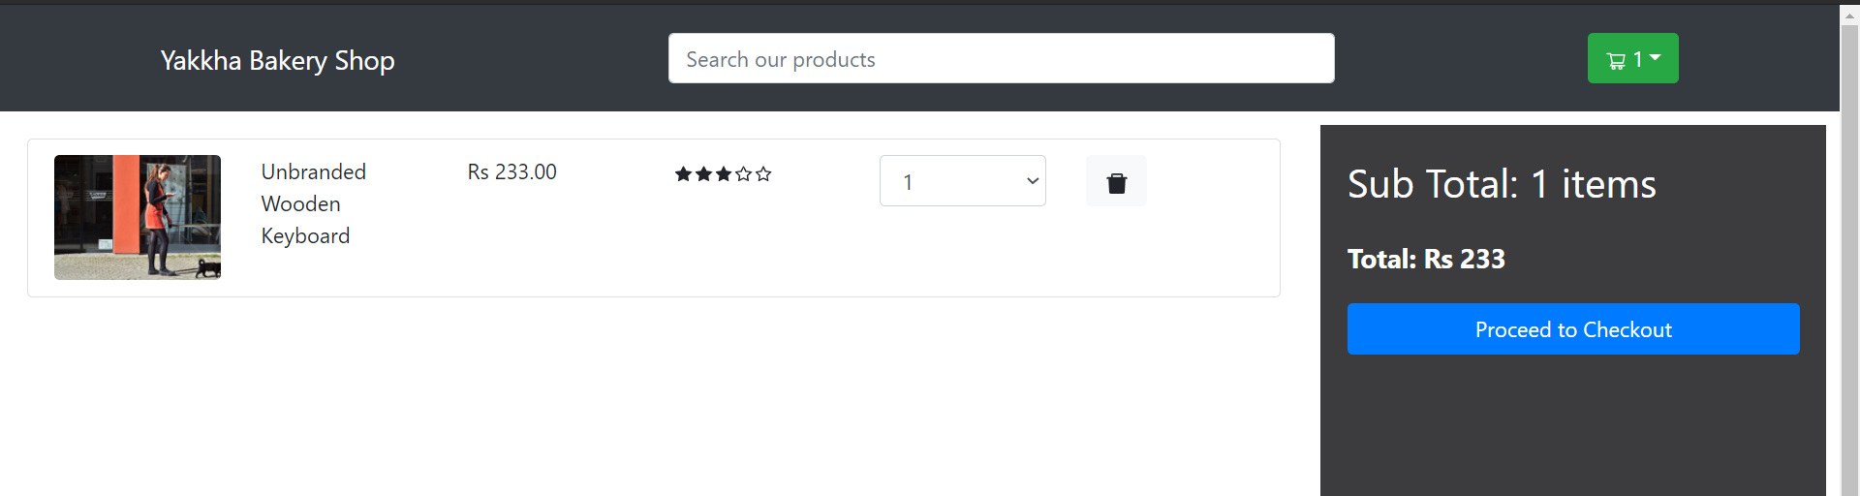

# CHANGE CART QUANTITY FUNCTIONALITY

## Add action type in reducer.js

case "CHANGE_CART_QTY":

            return {

                ...state,

                cart: state.cart.filter((c) =>

                c.id === action.payload.id ? (c.qty= action.payload.qty) : c.qty

                ),

            }

Cart.js

   <Col md={2}>

                                    <Form.Control

                                     as="select"

                                     value={prod.qty}

                                     onChange={(e) =>

                                     dispatch({

                                         type:"CHANGE_CART_QTY",

                                         payload: {

                                             id:prod.id,

                                             qty: e.target.value,

                                         },

                                     })}

                                     >

                                        {

                                            [...Array(prod.inStock).keys()].map((x) =>(

                                                <option key={x+1}>{x+1}</option>

                                            ))

                                        }

                                    </Form.Control>

                                </Col>

# FILTERS IMPLEMENTATION

# Filters useReducer:

## CREATE USEREDUCER IN CONTEXT.JS

const [productState, productDispatch] = useReducer(productReducer, {

        byStock: false,

        byFastDelivery: false,

        byRating:0,

        searchQuery: "",

    })

        <Cart.Provider value={{state,dispatch,productState,productDispatch}}>

## CREATING productReducer IN Reducers.js

export const productReducer = (state,action) =>{}

## Import productReducer in Context.js

import { cartReducer,productReducer } from './Reducers';

## MANIPULATE STATE IN REDUCERS

export const productReducer = (state,action) =>{

    switch (action.type){

        case "SORT_BY_PRICE":

            return {...state,sort: action.payload};

        case "FILTER_BY_STOCK":

            return {...state,byStock: !state.byStock};

        case "FILTER_BY_DELIVERY":

            return {...state,byFastDelivery: !state.byFastDelivery};

        case "FILTER_BY_RATING":

            return {...state,byRating: action.payload};

        case "FILTER_BY_SEARCH":

            return {...state,searchQuery: action.payload};

        case 'CLEAR_FILTER':

            return {

                byStock: false,

                byFastDelivery: false,

                byRating:0,

                searchQuery: "",

            };

        default:

            return state;

    }

}

## NOW IMPLEMENTING ON OUR APP

Import CartState() in Filters.js

import {CartState} from ".../context/Context";

    const {productState,productDispatch} = CartState();

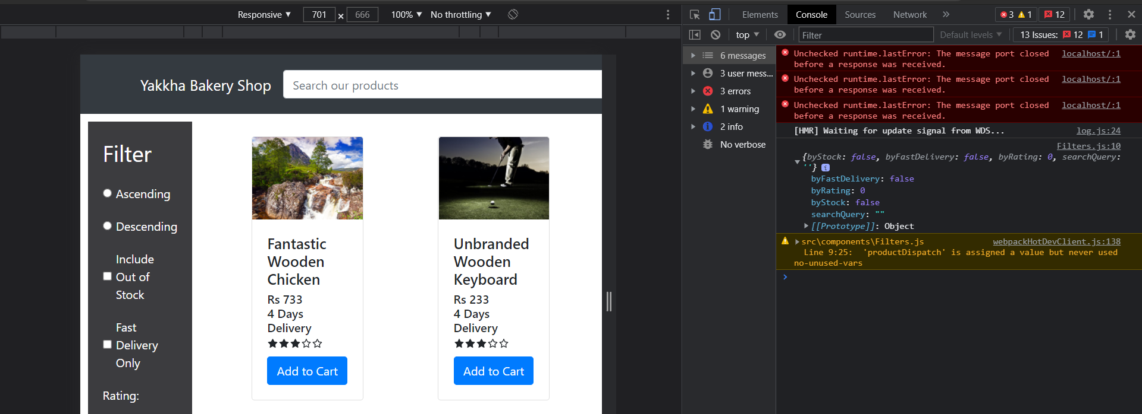

Filters.js

import React,{useState} from 'react'

import { Button,Form } from 'react-bootstrap'

import Rating from './Rating';

import {CartState} from "../context/Context";

const Filters = () => {

    const {

        productState:{byStock,byFastDelivery,sort,byRating},

        productDispatch,

    } = CartState();

    console.log(byStock,byFastDelivery,sort,byRating);

    return (

        <div className='filters'>

            <span className='title'>Filter</span>

            <span>

                <Form.Check

                 inline

                 label="Ascending"

                 name="group1"

                 type="radio"

                 id={`inline-1`}

                 onChange={() =>

                 productDispatch({

                     type: "SORT_BY_PRICE",

                     payload: "lowToHigh",

                 })}

                 checked={sort === "lowToHigh" ? true: false}

                 />

            </span>

            <span>

                <Form.Check

                 inline

                 label="Descending"

                 name="group1"

                 type="radio"

                 id={`inline-2`}

                 onChange={() =>

                 productDispatch({

                     type: "SORT_BY_PRICE",

                     payload: "highToLow",

                 })}

                 checked={sort === "highToLow" ? true: false}

                 />

            </span>

            <span>

                <Form.Check

                 inline

                 label="Include Out of Stock"

                 name="group1"

                 type="checkbox"

                 id={`inline-3`}

                 onChange={() =>

                 productDispatch({

                     type: "FILTER_BY_STOCK",

                 })}

                 checked={byStock}

                 />

            </span>

            <span>

                <Form.Check

                 inline

                 label="Fast Delivery Only"

                 name="group1"

                 type="checkbox"

                 id={`inline-4`}

                 onChange={() =>

                 productDispatch({

                     type: "FILTER_BY_DELIVERY",

                 })}

                 checked={byFastDelivery}

                 />

            </span>

            <span>

                <label style={{paddingRight: 10}}>Rating:</label>

                <Rating

                rating={byRating}

                onClick = {(i) =>

                productDispatch({

                    type:"FILTER_BY_RATING",

                    payload: i+1,

                })

                }

                style={{cursor: "pointed"}} />

            </span>

            <Button

variant="light">Clear</Button>

        </div>

    )

}

export default Filters

SS:  


ADD CLEAR FILTER:

<Button

             variant="light"

             onClick={()=>

                productDispatch({

                    type: "CLEAR_FILTER",

                })

             }

            >Clear</Button>

## NOW SEARCH BUTTON OF HEADER.JS

Header.js

import React from 'react'

import { Container,FormControl,Navbar,Dropdown,Button } from 'react-bootstrap'

import {Link} from "react-router-dom";

import {AiOutlineShoppingCart,AiFillDelete} from "react-icons/ai"

import { CartState } from '../context/Context';

const Header = () => {

    const {

        state: {cart},

        dispatch,

        productDispatch,

    } = CartState()

    return (

        <Navbar bg='dark' variant='dark'

        style={{height:80}}>

            <Container>

                <Navbar.Brand>

                    <Link to="/">Yakkha Bakery Shop</Link>

                </Navbar.Brand>

                <Navbar.Text className='search'>

                    <FormControl

                        style={{width:500}}

                        placeholder='Search our products'

                        className='m-auto'

                        onChange={(e) =>{

                            productDispatch({

                                type:"FILTER_BY_SEARCH",

                                payload: e.target.value,

                            });

                        }}

                    />

                </Navbar.Text>

Filters.js

        productState:{byStock,byFastDelivery,sort,byRating,searchQuery},

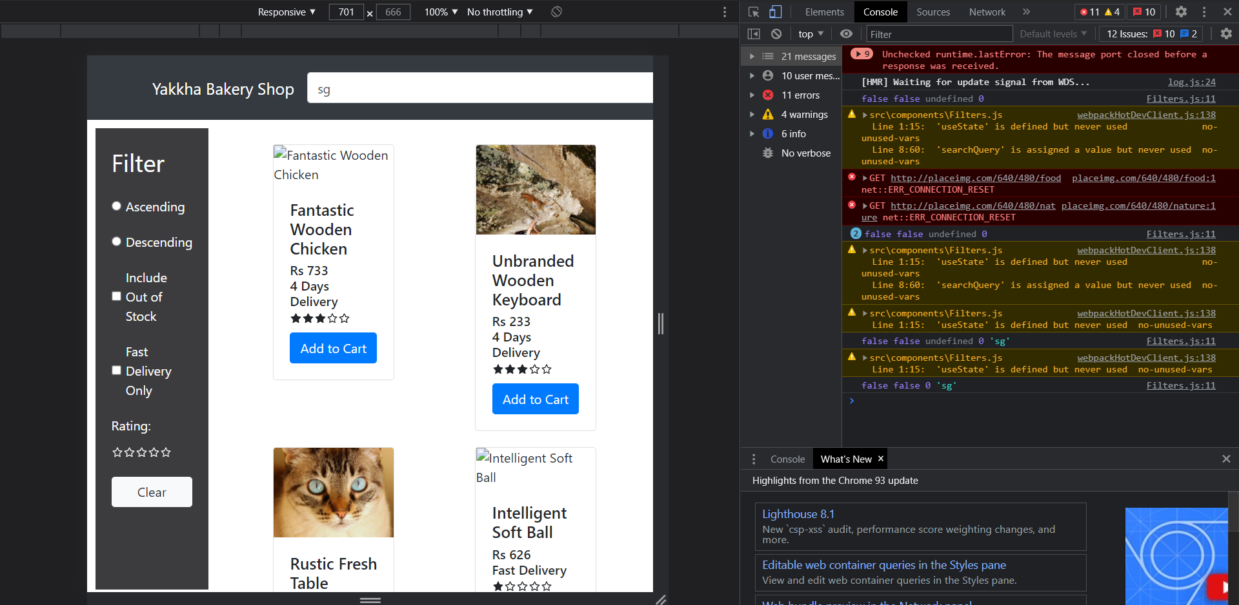

# TRANSFORM PRODUCTS LOGIC

## First bring all product state from context api

Home.js

const {

        state : {products},

        productState:{byStock,byFastDelivery,sort,byRating,searchQuery,},

    } = CartState();

## Logical Function to render products according to filters

//logical function to render products according filter

    const transformProducts = () => {

        let sortedProducts = products;

        //checking if there is sthg in sort like any highTolow like these and we will manipulate sortedProducts

        if(sort){

            sortedProducts = sortedProducts.sort((a,b) =>(

                sort==='lowToHigh'?a.price-b.price:b.price-a.price

            ));

        }

        return sortedProducts

    }

## Return method of Home.js

return (

        <div className='home'>

            <Filters/>

            <div className='productContainer'>

                {transformProducts().map((prod,idx) => {

                    return <SingleProduct prod={prod} key={idx} />

                })}

            </div>

        </div>

    )

## Displaying those which are out of stock in home.js

if(!byStock){

            sortedProducts = sortedProducts.filter((prod) => prod.inStock);

        }

## Displaying those which are fast delivery in home.js

if(byFastDelivery){

            sortedProducts = sortedProducts.filter((prod) => prod.byFastDelivery);

        }

## Displaying according to rating filters

 if(byRating){

            sortedProducts = sortedProducts.filter(

                (prod) => prod.ratings >=byRating

                );

        }

## Searching

    if(searchQuery){

            sortedProducts = sortedProducts.filter(

                (prod) => prod.name.toLowerCase().includes(searchQuery)

                );

        }

# MOBILE RESPONSIVE STYLES

Styles.css

@media (max-width: 771px){

}